Alexander Gilman

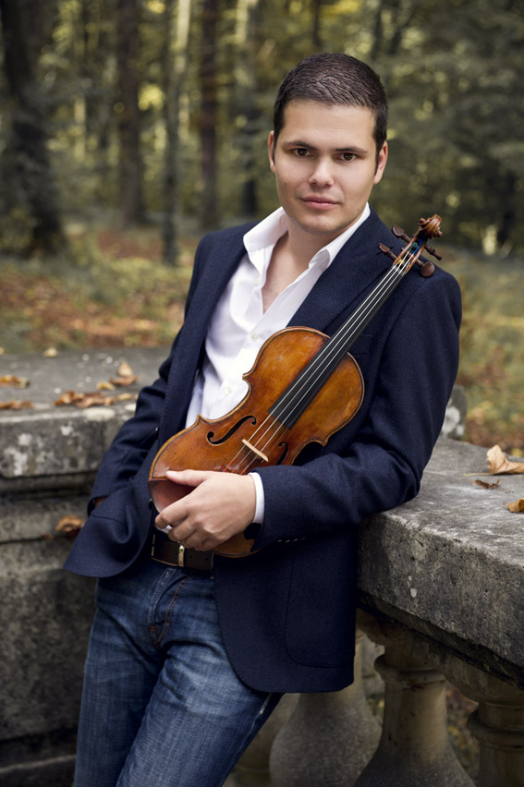
“Gilman is a name to watch” titled the Classic FM magazine in 2007. Today, Alexander Gilman is one of his generation’s most promising violinists. After giving his first solo concert at age seven in Munich, Germany Philharmonic Concert Hall, Alexander Gilman has now performed in the most renowned concert halls all over the world.

The violinist has worked with conductors such as Neeme Järvi, David Zinman, Bernard Haitink, Eri Klas, Perry So, Michael Sanderling and many others and is regularly invited to major international music festivals as a soloist, chamber musician and lecturer.

Last year Alexander released his new CD with the violin concertos by S. Barber and E. Korngold, the Carmen Fantasy by F. Waxman and the Theme from Schindler's List by J. Williams, recorded with the Cape Town Philharmonic Orchestra under the baton of Perry So.

The recording received the prestigious Diapason d´Or award; furthermore it was chosen as CD of the week by the Financial Times Germany, CD-Tip by the Bavarian Broadcast, Sound-Tip by the Audio Magazine and received plenty of more outstanding reviews in the classical music press.

His debut CD on OehmsClassics with works by J. Brahms, S. Prokofiev, H. Wieniawski, and S. Foster, recorded with pianist Marina Seltenreich, was released in 2007. The Strad, among others, was highly enthusiastic about Alexander Gilman’s “impeccable intonation” and “superb sound quality”, while other major magazines such as FonoForum and Ensemble called the CD “a highly successful start” and “a fantastic debut”.
In the following season, concerts and master classes will take Alexander through Europe as well as to the American, Australian and African continents.

Born in Bamberg, Germany in 1982, Alexander Gilman grew up in a musically acclaimed family of Russian Jewish descent. At a very young age, the young virtuoso amazed audiences with performances in concerts, TV, radio and competitions.

In 2006 he won the WestLB competition and was given use of the “ex Croall” Stradivarius (1684), which was handed over to him by Frank Peter Zimmermann. He is also the prizewinner of international competitions in the USA and Europe. In 2008, Alexander Gilman won a J.B. Guadagnini violin from the German Instrument Fund of the Stiftung Musikleben.

The violinist graduated with distinction from the Academy of Music in Cologne in the Master Class of Prof. Zakhar Bron and went on to obtain his Master of Arts at the University of Music in Zurich. Among others, Alexander has worked with Dorothy Delay and attended master classes with Itzhak Perlman, Aaron Rosand, Igor Ozim and Mikhail Kopelman.

Alexander Gilman has been teaching as an assistant to Prof. Bron at the University of Music in Zurich since 2010. Beginning in 2013 he has also assumed another teaching position at the prestigious AMADEUS Music Academy in Vienna. Furthermore, he holds worldwide master classes at universities and music festivals on a regular basis .

Alexander currently plays the J.B. Guadagnini violin (Parma 1761).

